Day #4 – Can I work from home doing this?

So, yesterday we discussed how this was possible for anyone, everyone – even someone like you.

By the time I finish with this program you are going to throw out that bag of excuses. That is my objective.

With that in mind, I know the next thing coming up. Eric, can I do this from home because I don’t have money for an office space.

So today, we are going to go one step further. Not only will I explain to you how you can do it from home – we will discuss the tools that you need to effectively do it.

See for yourself in the upcoming lesson.

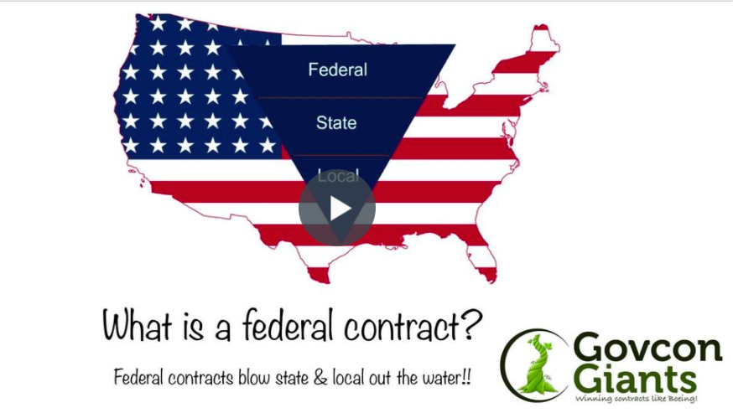

Learn how to start your “garage business” like other millionaires by clicking the link below.

Day #4 Home Based Business

See you manana!

Eric Coffie

